**Photoreal Scenery – Basic Instructions for MSFS (For FSET verion 1.4 and above)**

FSET allows for the creation of photo scenery with proper water masking, nights and seasons textures, and autogen data for FS2004, FSX, P3D, and MSFS (please see separate readme for instructions for FS2004, FSX, and P3D).

The below is how to create the scenery.

Note that the FSET manual is the file called UserDocu.pdf inside the Docs directory. But this is from the original FSET which did not have automatic water masking nor MSFS support.

# 1. FS Earth Tiles

1. In this zip file you will find FSET (stand-alone application), already set up and ready to go.
2. Please install the MSFS SDK. See here for instructions:

<https://forums.flightsimulator.com/t/how-to-getting-started-with-the-sdk-dev-mode/123241>

1. After installing the SDK, navigate to the folder you installed it to. Then find Tools\bin. Inside the bin folder, find fspackagetool.exe. Place this file inside the unzipped FSET folder.
2. Set the working folder (where temporary files used by FSET are placed) as well as the Add-on Scenery folder (where the output package folder will be placed) in the top of the FSET window. Due to a bug in the current fspackagetool.exe, these paths can’t have a space in them, otherwise the program will not work.
3. Next, click on FSEarthTiles.exe. Maximize the window. Find the area you would like to create a scenery for. Click on "Draw" and draw the area on the map.
4. Select MSFS2020 from the dropdown which says “Scen. Compiler”:

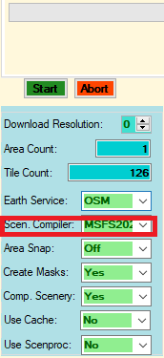

1. You can select which server to download from with the “Earth Service” dropdown and the download resolution using the “Download Resolution” dropdown.
2. Once done, click “Start”, and the scenery will automatically be created. The “Create Masks”, and “Use Scenproc” settings are ignored for MSFS.
3. The number of simultaneous downloads can be controlled with MaxDownloadThreads in FSEarthTiles.ini. Increase this number to increase the speed of downloads (up to a certain point. It depends on your own computer and download speeds, as well as the speed of the download server). The default value is 16 threads.
4. Now, wait until the process is finished. FSET will download the imagery at the resolution corresponding to whatever zoom level you choose.
5. After the scenery is downloaded, fspackage tool will launch. Note, that due to a bug in sim update 9, fspackage tool will also launch the MSFS splash screen. The splash screen will display an error, which is normal (does not affect the package creation):

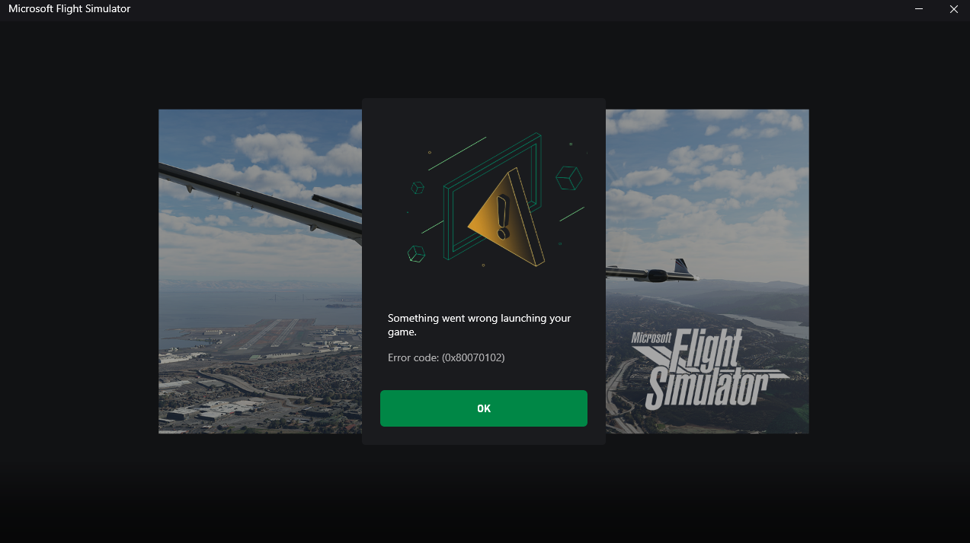

It is very important to not press okay until you see “done” in the black fspackagetool command prompt:



After you see that, press done on the MSFS splash window. Hopefully when Asobo fixes this bug with fspackagetool, pressing OK will not be necessary, and fspackagetool will just exit by itself…

1. When finished, the bottom left notification area will say "Done".
2. The scenery you have created can be found in whichever directory you set the Add-on scenery folder to. Inside this folder will be a Packages folder. Inside Packages will be your newly created scenery with the name “fset-aerial”. This can be renamed to whatever you want and placed inside your Community folder.

Note: FSPackagetool takes quite a while to compile packages and gives no indication of progress. Be patient, especially for large areas!

**To add more sources from which to download imagery:**

There are two ways:

1. Look in UserDocu.pdf (the main FSET manual) for how to add more providers to FSEarthtiles.ini.
2. Using Ortho4XP providers*. Providers from Ortho4XP have been provided in this package. They are under the “Providers” folder. Inside, you will find .lay files. If you want to activate a provider, open the .lay file with a text editor such as Notepad. Then, add this line “in_GUI=True”.
   1. You can also find more Ortho4XP providers online. Just drop them into a sub folder of the “Providers” folder.

* Note: not all Ortho4XP providers work in FSET. Support for them is an ongoing process and will be added as time permits.